**PLUGGING INTO THE FUTURE: AN EXPLORATION OF ELECTRICITY CONSUMPTION PATERNS**

Submitted by

**E. Valarmathy**

(Reg.No.12020U25034)

**U. Usha**

(Reg.No.12020U25033)

**M. Vinothini**

(Reg.No.12020U25035)

**S. Yugavarthini**

(Reg.No.12020U25036)

**DEPARTMENT OF**

**BACHELOR OF SCIENCE IN**

**MATHEMATICS**

**KRISHNASAMY COLLEGE OF**

**SCIENCE, ARTS AND MANAGEMENT**

**FOR WOMEN-CUDDALORE**

**PROJECT CONTENT**

1. INTRODUCTION
   1. Overview
   2. Purpose
2. PROBLEMS DEFINITIONS & DESIGN THINKING
   1. Empathy Map
   2. Ideation & Brainstroming
3. RESULT

1. ADVANTAGES AND DISADVANTAGES
2. APPLICATIONS
3. CONCLUSION
4. FUTURE SCOPE

8. APPENDIX

A. SQL Server Code A. SQL

B. HTML Source Code

**1. INTRODUCTION:**

1.1. OVERVIEW

India is the world’s third-largest producer and third largest consumer of electricity. The1 national electric grid in1 India has an installed capaci1ty of 370.106 GW as of 31 March 2020. Renewable power plants,which also include large hydroelectric plants, constitute 35.86% of India’s total installed capacity. During the fiscal year(FY) 2019-20,the total electricity generation in the country was 1,598TWh, of which 1,383.5TWh generated by utilities. The gross electricity consumption per capita in FY2019 was 1,208 kWh.

1.2. PURPOSE

In this project , our important purposes are to analysis the Consumption Pattern of Electricity. Annual electricity consumption per capita serves as an important measure of a country’s electric power development. Generally speaking, electricity consumption grows faster when the industrialisation process develops quickly and goes down rapidly when industrialization is completed or near completion.

**2. PROBLEM DEFINITION AND DESIGN THINKING:**

2.1. EMPATHY MAP

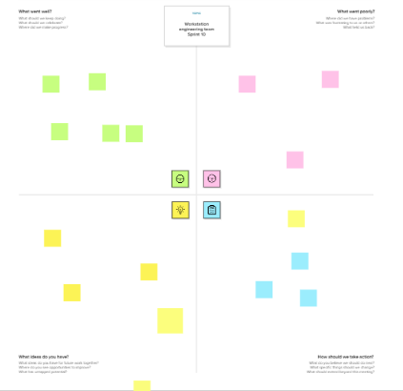

2.2 Ideation & Brainstorming

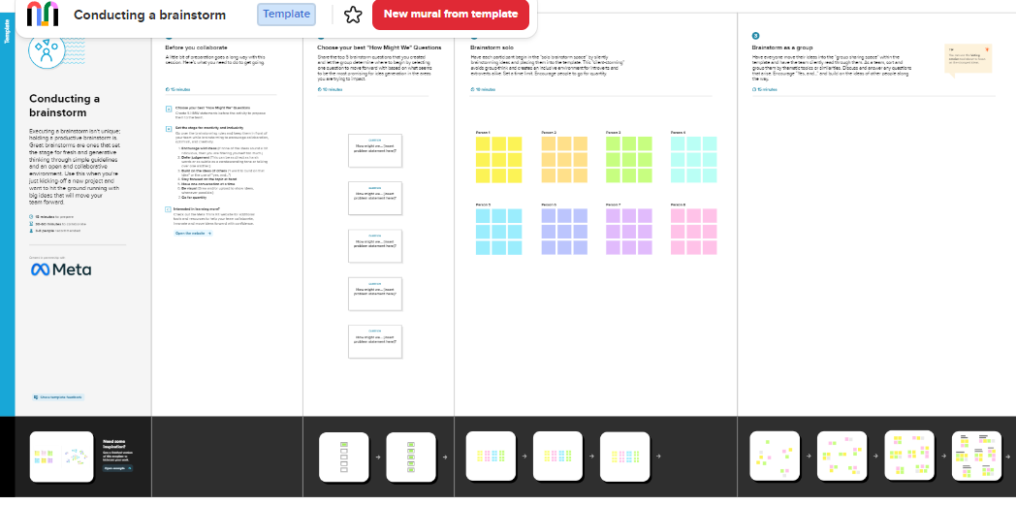

**3. RESULT:**

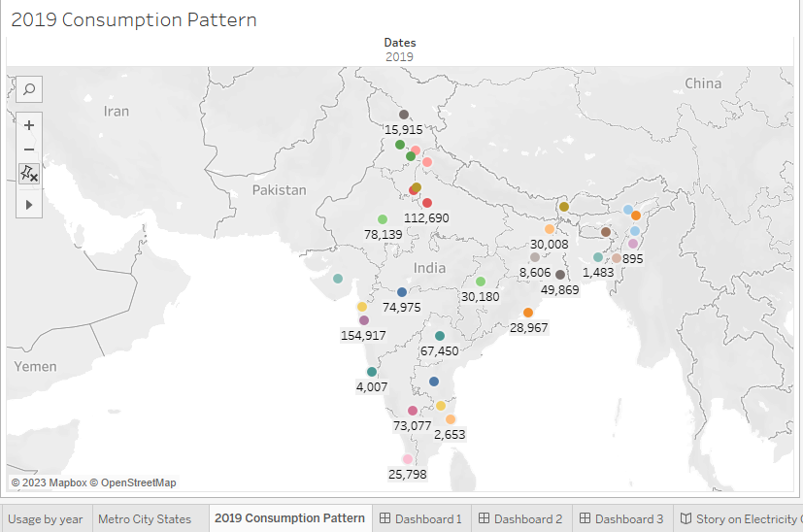

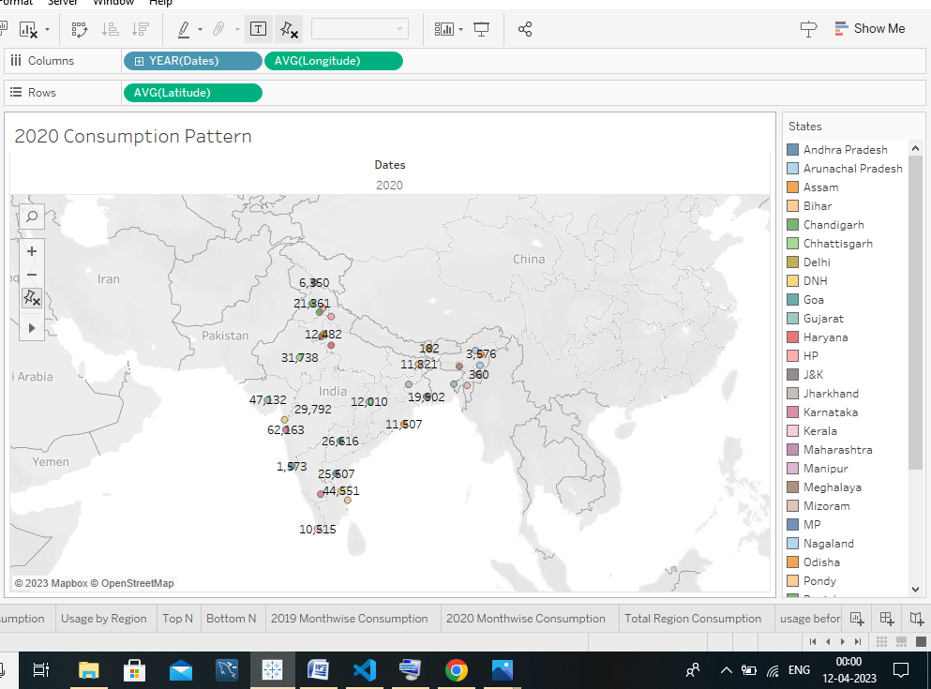 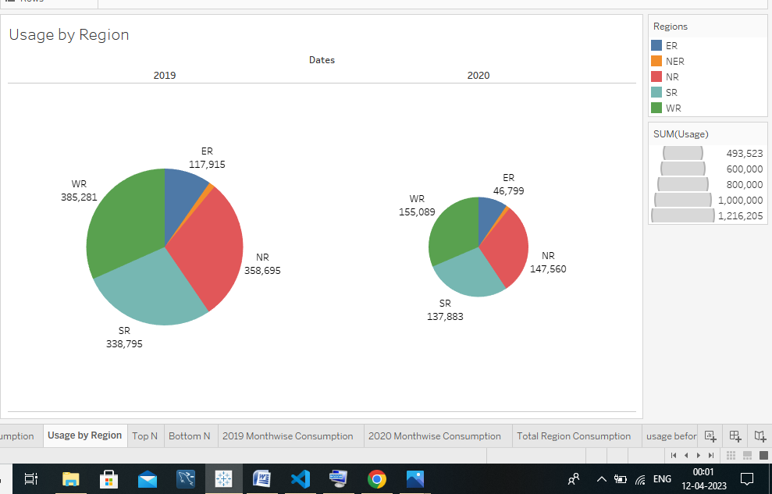 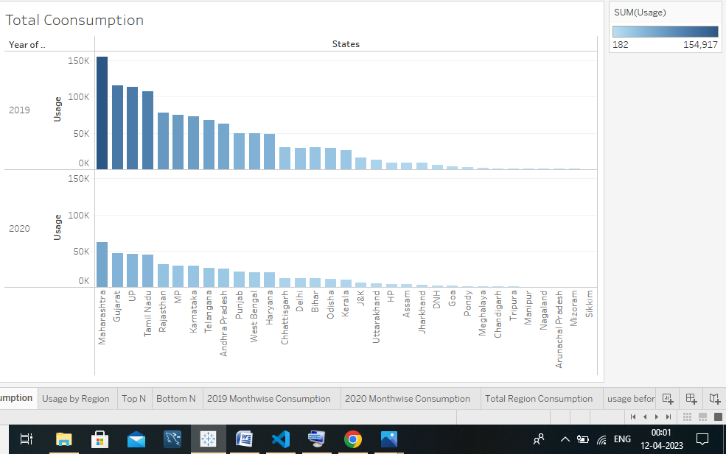

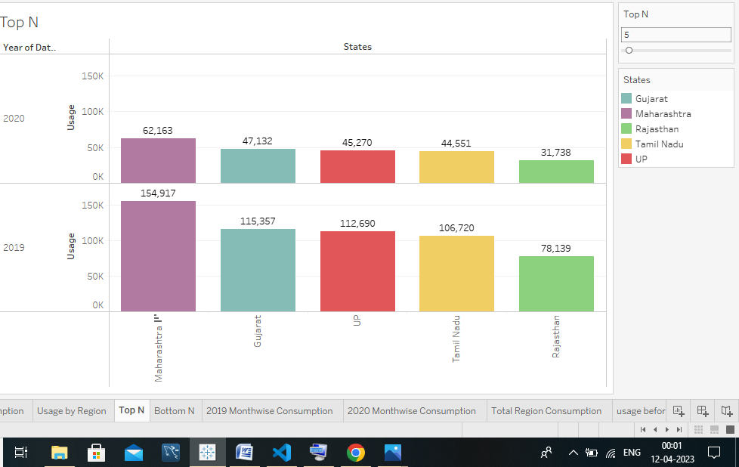

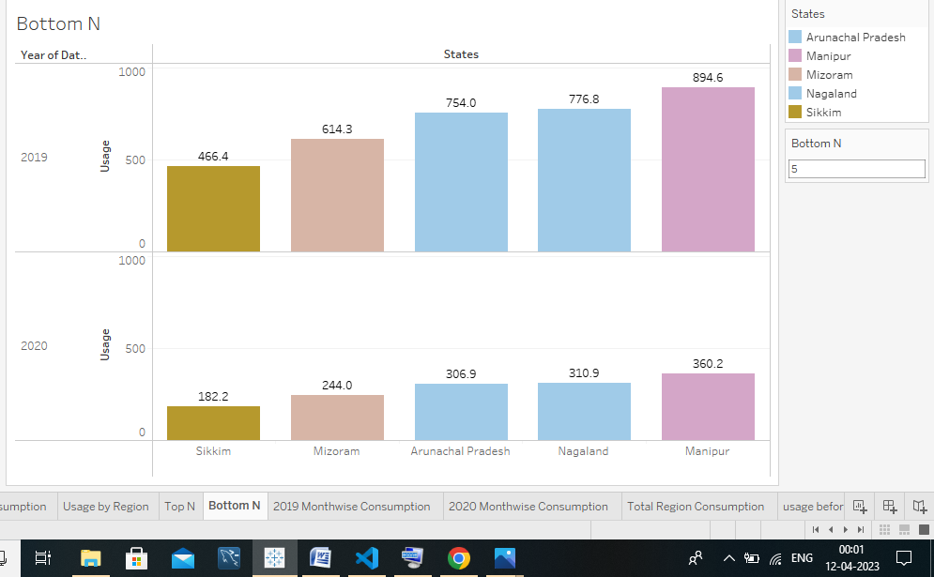

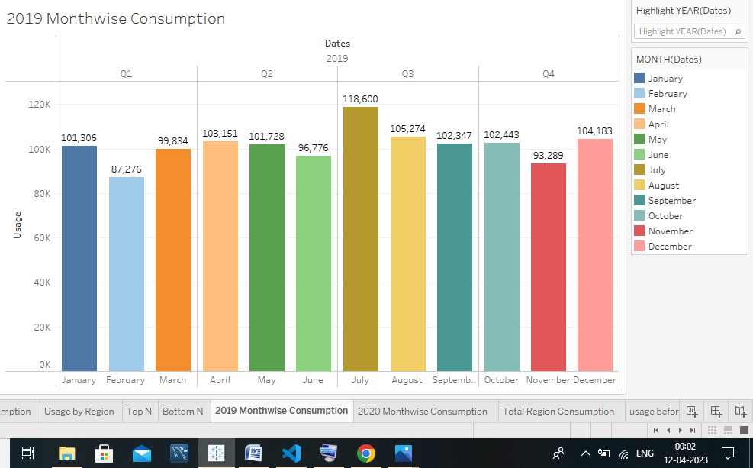

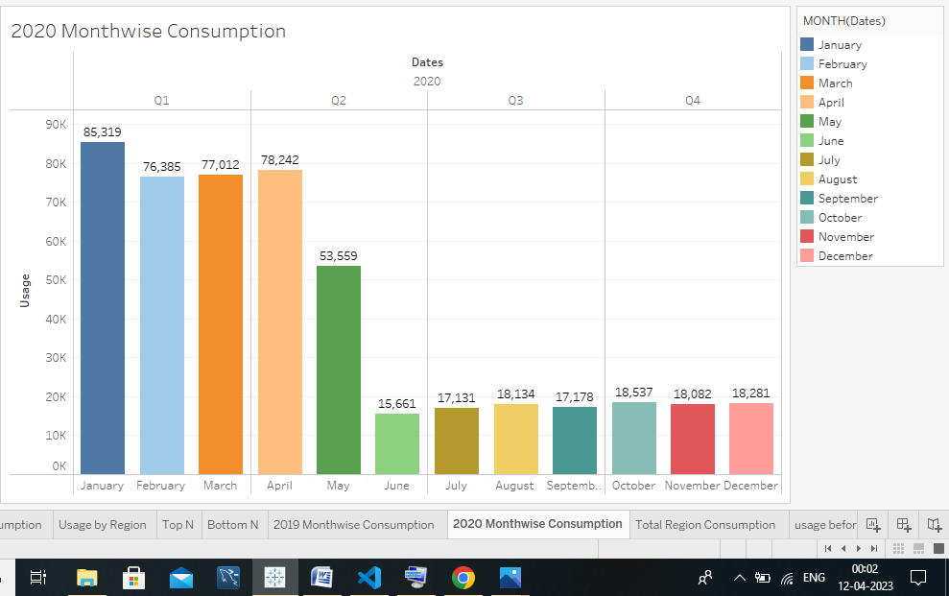

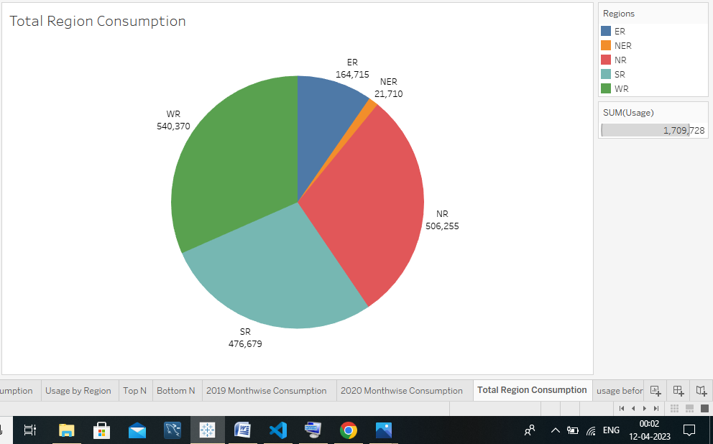

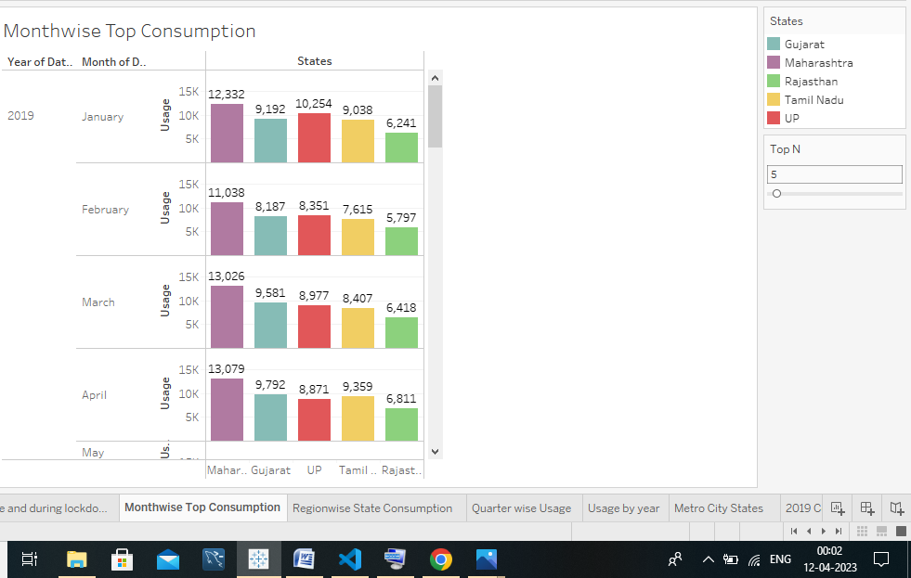 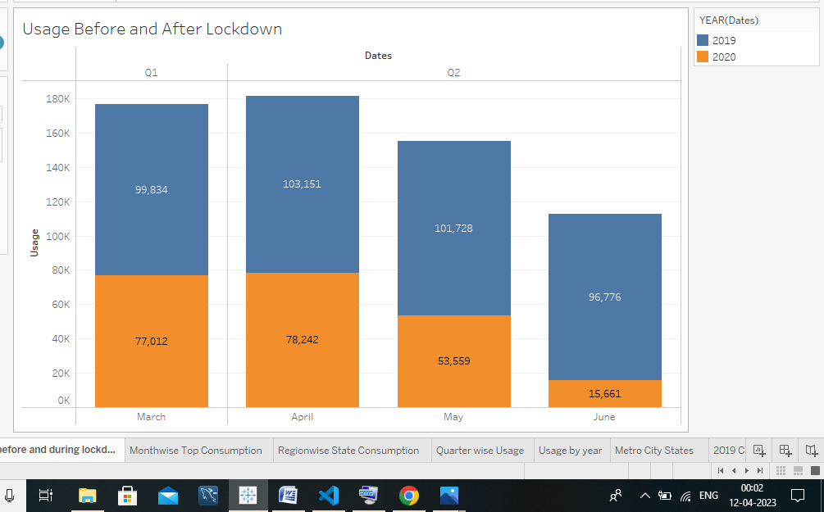

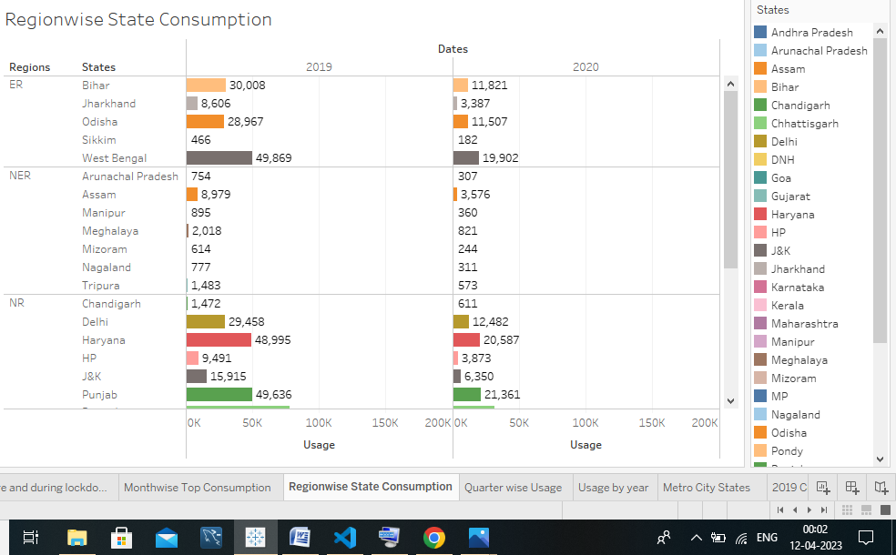

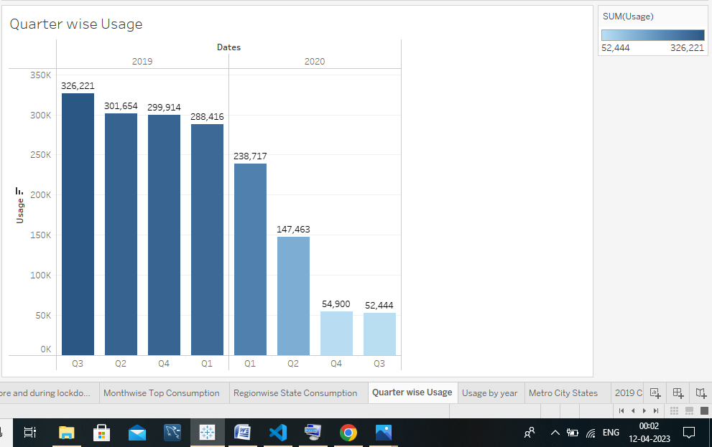

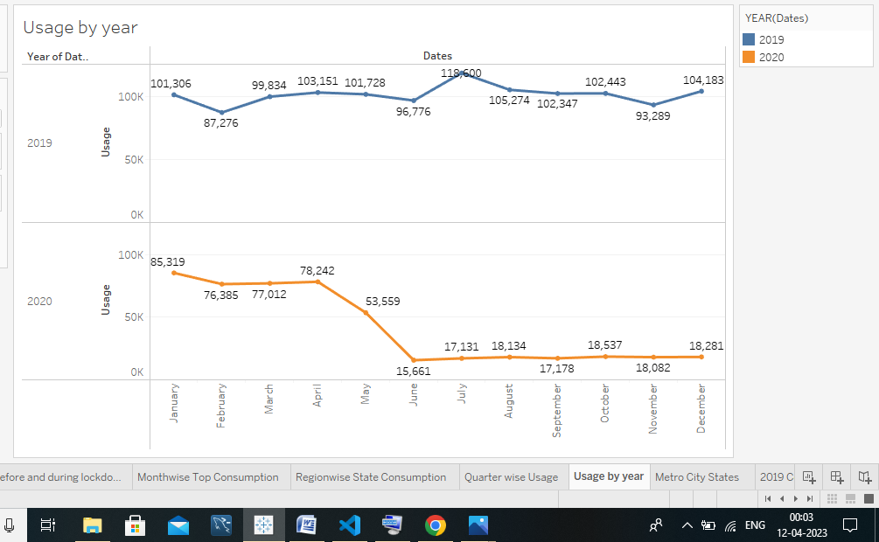

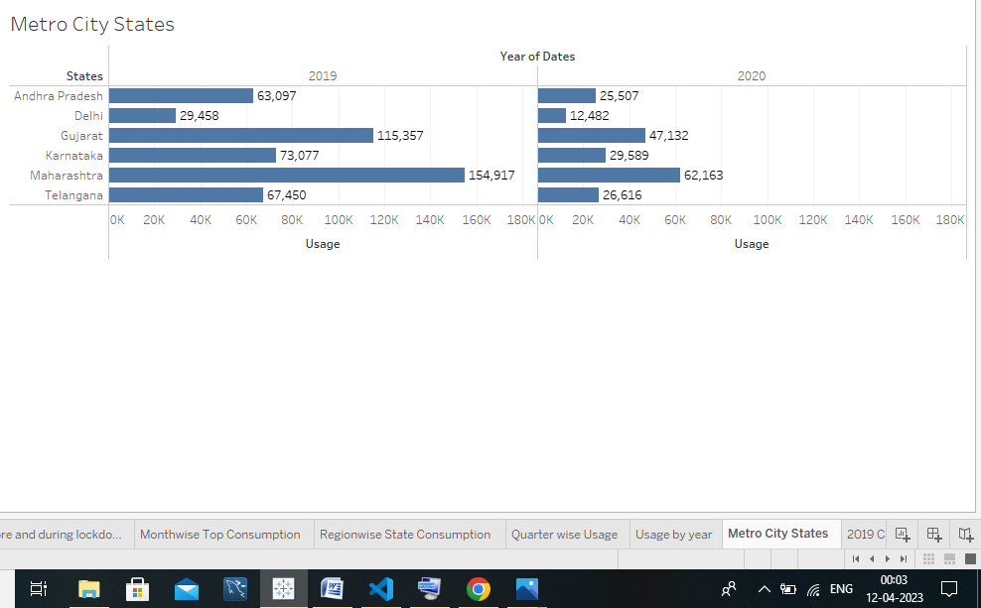

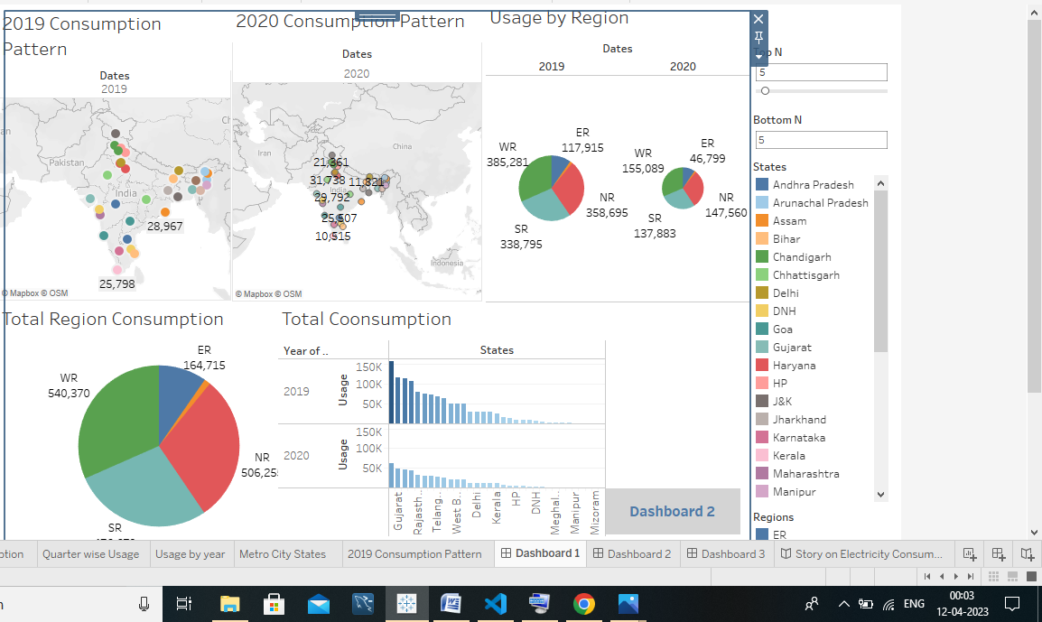

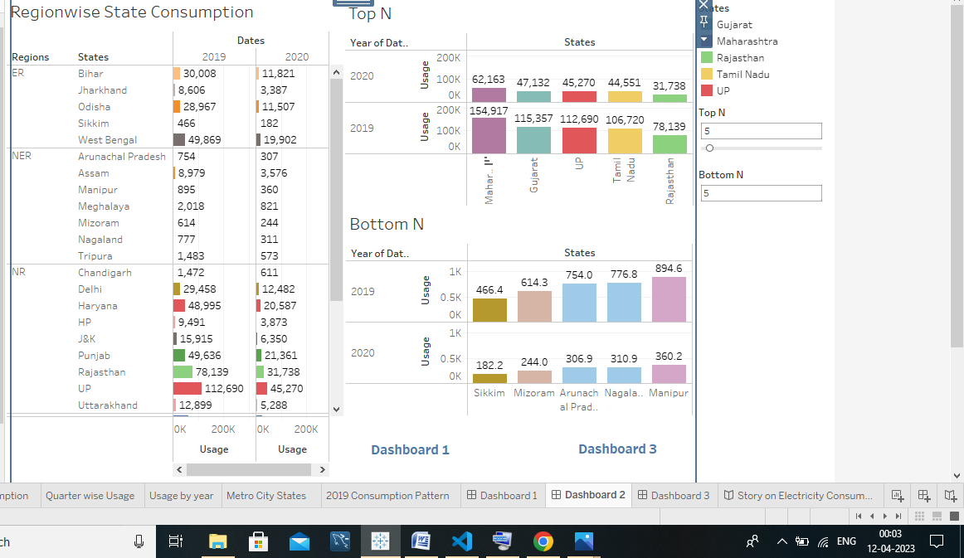

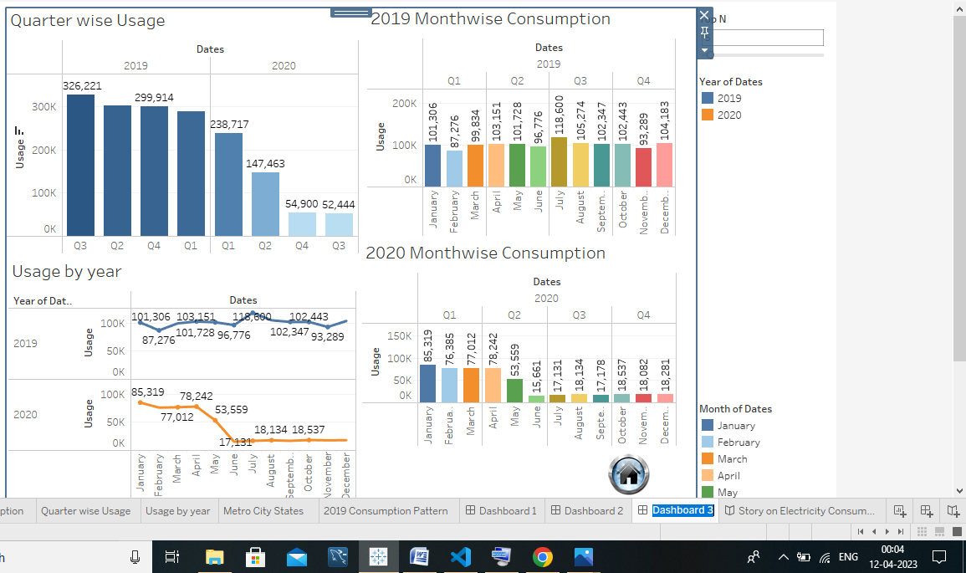

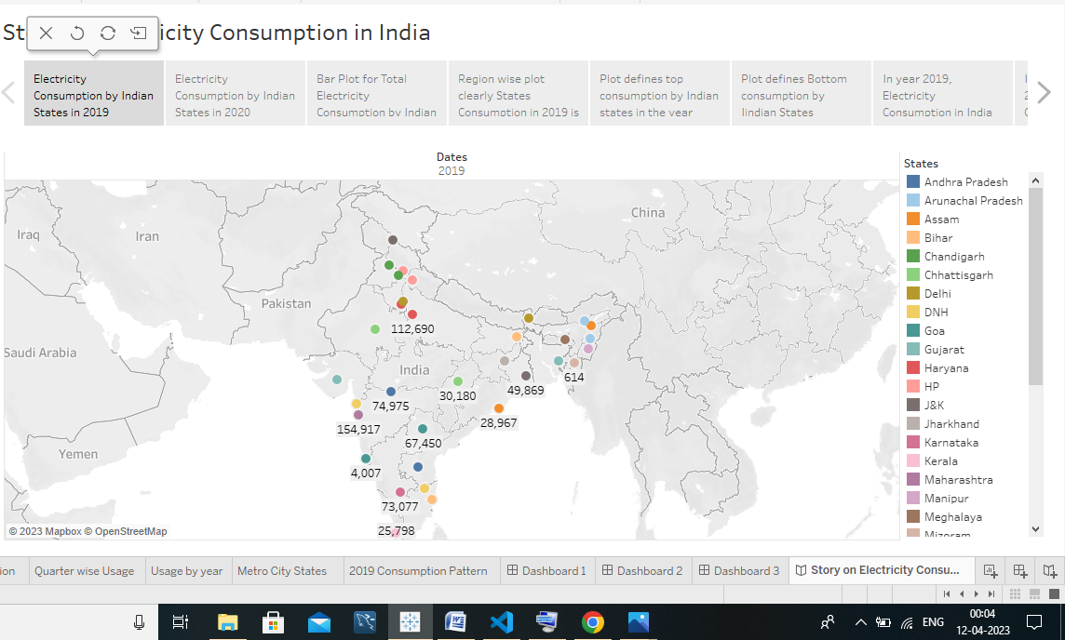

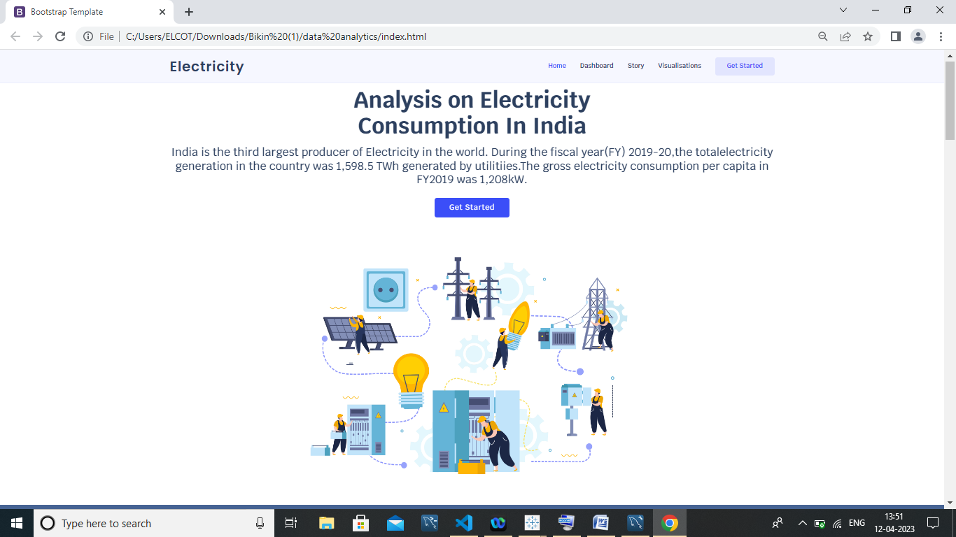

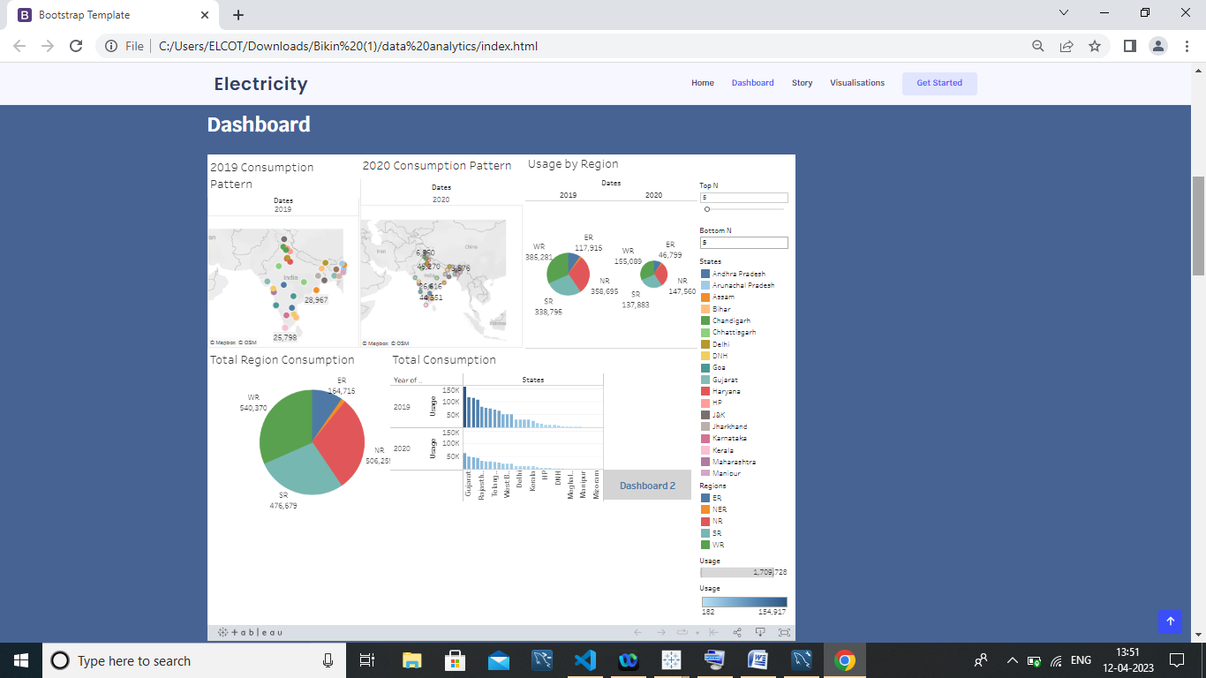

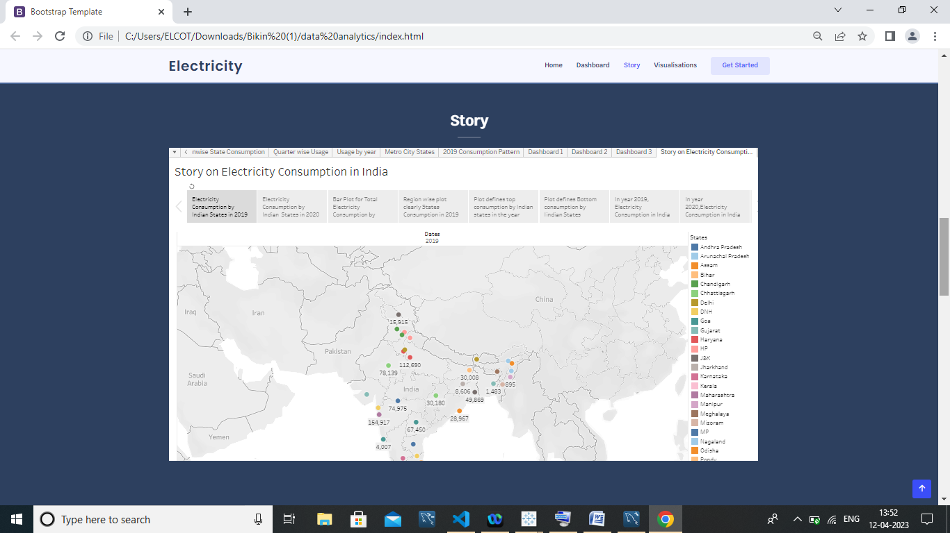

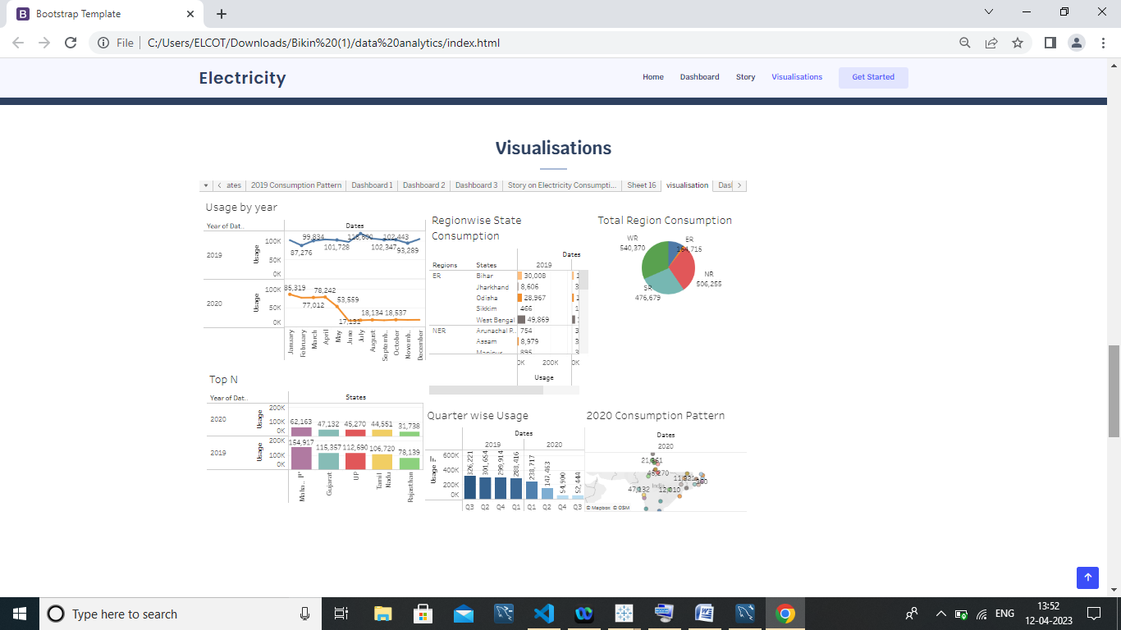

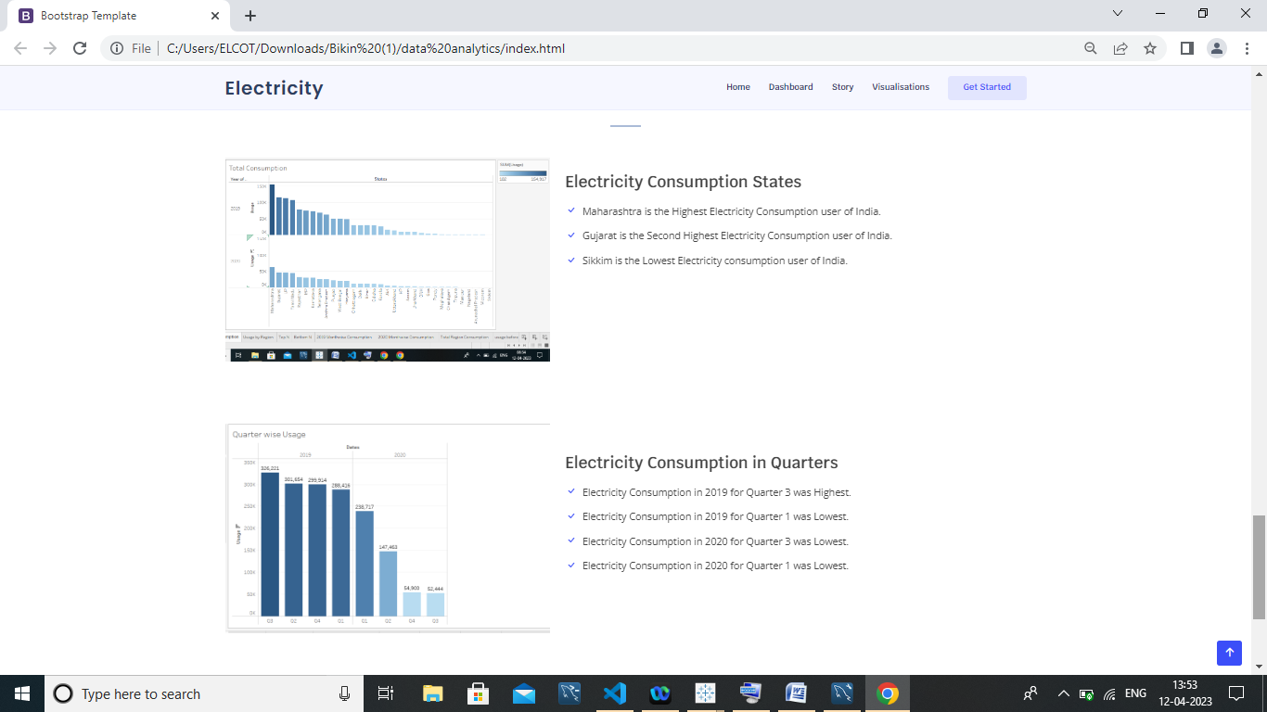

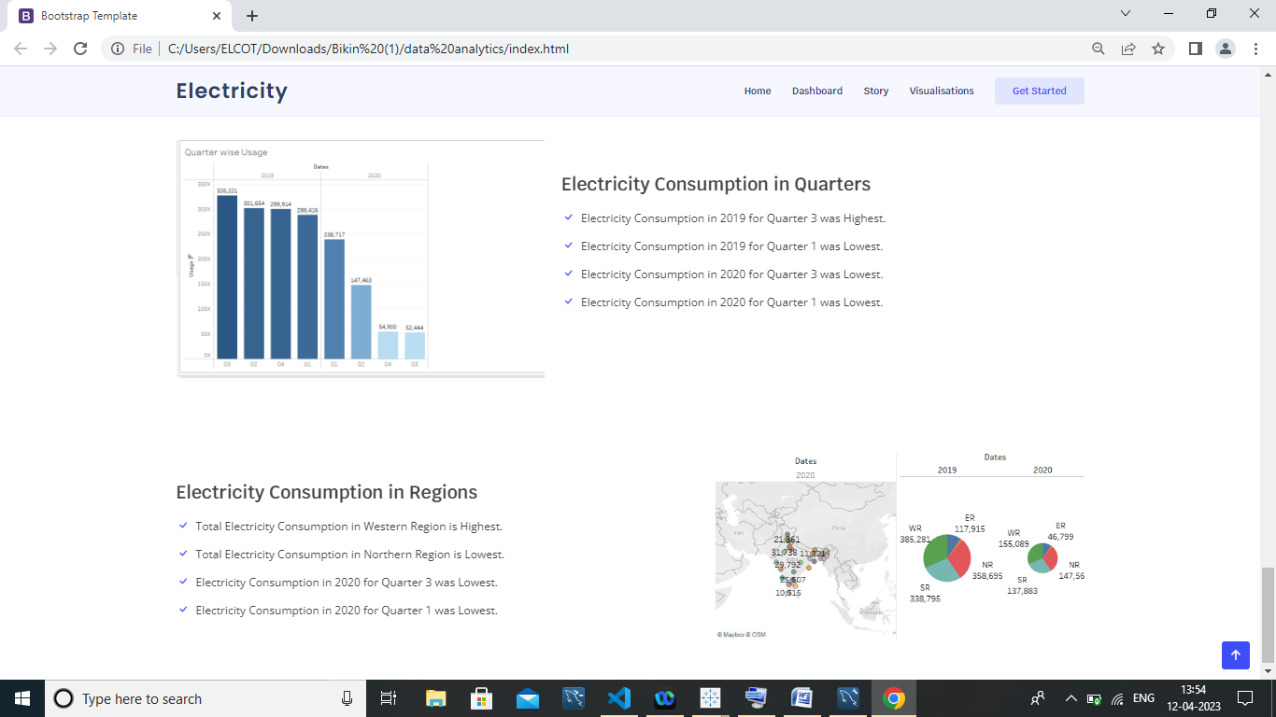

**4. ADVANTAGES AND DISADVANTAGES:**

ADVANTAGES

Electric power has many advantages domestically and industrially,as most of the equipment run by electric power. Brightness in the night is only possible by the use of electricity. Almost all the factories and industries are running due to electric power. The advantages of electric power is its reliable and uninterrupted supply runs the equipment efficiently and continuously. The transportation of electricity is easy once the transmission lines are functional. They work for years and need no or very less maintenance. The invention of electric power is one of the best inventions which have changed human life drastically. It allows people to do more leisure activities.

DISADVANTAGES

In the conventional system to generate electric power, coal is steam produced is used to run the turbines which in turn generate electricity which produces too much air pollution as a by-produce. Due to the burning of coal, carbon monoxide, different oxides of sulphur and nitrogen are pumped into the atmosphere which pollutes it badly. As carbon dioxide is the greenhouse gas and its excessive presence in the atmosphere raises the earth’s temperature.

Distribution of electric power is in two types of Current, AC and DC. Alternating Current is 3 to 4 times more dangerous as compared to Direct Current. It causes more muscle contraction as it reduces skin resistance by stimulating sweating.

**5. APPLICATIONS:**

**In Industries**

The industrial sector uses electricity for operating industrial motors and machinery, lights, computers and office equipment, and for facility heating, cooling, and ventilation.

The most direct role of enery is that of an input to production. In effect, a world without electricity amounts to non-mechanized production. While erratic supplies of electricity disrupt production, Voltage fluctuations negatively affect the durability of machines.

**In Households**

Starting from toasters to refrigerators, microwaves, washing machines, dishwashers, electrical chimneys, and many more appliances which are simple to use and made for the convenience of day-to-day activities use electricity to function.

**6.CONCLUSION:**

 Electricity is the backbone of modern society. Our life will go back to the primitive age without electricity. There is a need for rational use of electricity, as it is largely produced from non-renewable sources like coal and water.

1. **FUTURE SCOPE:**

In the Stated Policies Scenario, **global electricity demand grows at 2.1% per year to 2040**, twice the rate of primary energy demand. This raises electricity's share in total final energy consumption from 19% in 2018 to 24% in 2040. Electricity demand growth is set to be particularly strong in developing economies.

Energy systems can range in scope, from local, municipal, national, and regional, to global, depending on issues under investigation. Researchers may or may not include demand side measures within their definition of an energy system.

1. **APPENDIX:**
2. **SQL Source Code**

**create schema consumption_pattern;**

**use consumption_pattern;**

**select*from consumption;**

1. **HTML Source Code**

<!DOCTYPE html>

<html lang="en">

<head>

  <meta charset="utf-8">

  <meta content="width=device-width, initial-scale=1.0" name="viewport">

  <title> Bootstrap Template </title>

  <meta content="" name="description">

  <meta content="" name="keywords">

  <!-- Favicons -->

  <link href="assets/img/favicon.png" rel="icon">

  <link href="assets/img/apple-touch-icon.png" rel="apple-touch-icon">

  <!-- Google Fonts -->

  <link href="https://fonts.googleapis.com/css?family=Open+Sans:300,300i,400,400i,600,600i,700,700i|Krub:300,300i,400,400i,500,500i,600,600i,700,700i|Poppins:300,300i,400,400i,500,500i,600,600i,700,700i" rel="stylesheet">

  <!-- Vendor CSS Files -->

  <link href="assets/vendor/aos/aos.css" rel="stylesheet">

  <link href="assets/vendor/bootstrap/css/bootstrap.min.css" rel="stylesheet">

  <link href="assets/vendor/bootstrap-icons/bootstrap-icons.css" rel="stylesheet">

  <link href="assets/vendor/boxicons/css/boxicons.min.css" rel="stylesheet">

  <link href="assets/vendor/glightbox/css/glightbox.min.css" rel="stylesheet">

  <link href="assets/vendor/swiper/swiper-bundle.min.css" rel="stylesheet">

  <!-- Template Main CSS File -->

  <link href="assets/css/style.css" rel="stylesheet">

  <!-- =======================================================

  * Template Name: Bikin

  * Updated: Mar 10 2023 with Bootstrap v5.2.3

  * Template URL: https://bootstrapmade.com/bikin-free-simple-landing-page-template/

  * Author: BootstrapMade.com

  * License: https://bootstrapmade.com/license/

  ======================================================== -->

</head>

<body>

  <!-- ======= Header ======= -->

  <header id="header" class="fixed-top">

    <div class="container d-flex align-items-center justify-content-between">

      <h1 class="logo"><a href="index.html">Electricity</a></h1>

      <!-- Uncomment below if you prefer to use an image logo -->

      <!-- <a href="index.html" class="logo"><img src="assets/img/logo.png" alt="" class="img-fluid"></a>-->

      <nav id="navbar" class="navbar">

        <ul>

          <li><a class="nav-link scrollto active" href="#hero">Home</a></li>

          <li><a class="nav-link scrollto" href="#about">Dashboard</a></li>

          <li><a class="nav-link scrollto" href="#services">Story</a></li>

          <li><a class="nav-link scrollto " href="#portfolio">Visualisations</a></li>

          </li>

          <li><a class="getstarted scrollto" href="#about">Get Started</a></li>

        </ul>

        <i class="bi bi-list mobile-nav-toggle"></i>

      </nav><!-- .navbar -->

    </div>

  </header><!-- End Header -->

  <!-- ======= Hero Section ======= -->

  <section id="hero" class="d-flex align-items-center">

    <div class="container d-flex flex-column align-items-center justify-content-center" data-aos="fade-up">

      <h1>Analysis on Electricity Consumption In India</h1>

      <h2>India is the third largest producer of Electricity in the world. During the fiscal year(FY) 2019-20,the totalelectricity generation in the country was 1,598.5 TWh generated by utilitiies.The gross electricity consumption per capita in FY2019 was 1,208kW.</h2>

      <a href="#about" class="btn-get-started scrollto">Get Started</a>

      <img src="C:\Users\ELCOT\Downloads\Bikin\electricity template\assets\img\hero-img.png" class="img-fluid hero-img" alt="" data-aos="zoom-in" data-aos-delay="150">

    </div>

  </section><!-- End Hero -->

  <main id="main">

    <!-- ======= About Section ======= -->

    <section id="about" class="about">

      <div class="container">

        <div class="row no-gutters">

            <div class="content">

              <h3>Dashboard</h3>

              <div class='tableauPlaceholder' id='viz1681271990367' style='position: relative'><noscript><a href='#'><img alt='Dashboard 1 ' src='https:&#47;&#47;public.tableau.com&#47;static&#47;images&#47;bo&#47;book2_16811026424340&#47;Dashboard1&#47;1_rss.png' style='border: none' /></a></noscript><object class='tableauViz'  style='display:none;'><param name='host_url' value='https%3A%2F%2Fpublic.tableau.com%2F' /> <param name='embed_code_version' value='3' /> <param name='site_root' value='' /><param name='name' value='book2_16811026424340&#47;Dashboard1' /><param name='tabs' value='no' /><param name='toolbar' value='yes' /><param name='static_image' value='https:&#47;&#47;public.tableau.com&#47;static&#47;images&#47;bo&#47;book2_16811026424340&#47;Dashboard1&#47;1.png' /> <param name='animate_transition' value='yes' /><param name='display_static_image' value='yes' /><param name='display_spinner' value='yes' /><param name='display_overlay' value='yes' /><param name='display_count' value='yes' /><param name='language' value='en-US' /><param name='filter' value='publish=yes' /></object></div>                <script type='text/javascript'>                    var divElement = document.getElementById('viz1681271990367');                    var vizElement = divElement.getElementsByTagName('object')[0];                    if ( divElement.offsetWidth > 800 ) { vizElement.style.width='1000px';vizElement.style.height='827px';} else if ( divElement.offsetWidth > 500 ) { vizElement.style.width='1000px';vizElement.style.height='827px';} else { vizElement.style.width='100%';vizElement.style.height='1927px';}                     var scriptElement = document.createElement('script');                    scriptElement.src = 'https://public.tableau.com/javascripts/api/viz_v1.js';                    vizElement.parentNode.insertBefore(scriptElement, vizElement);                </script>

            </div>

        </div>

      </div>

    </section><!-- End About Section -->

    <!-- ======= Steps Section ======= -->

    <!-- ======= Services Section ======= -->

    <section id="services" class="services">

      <div class="container" data-aos="fade-up">

        <div class="section-title">

          <h2>Story</h2>

          <div class =

        <div class='tableauPlaceholder' id='viz1681272739326' style='position: relative'><noscript><a href='#'><img alt=' ' src='https:&#47;&#47;public.tableau.com&#47;static&#47;images&#47;bo&#47;book2_16811026424340&#47;StoryonElectricityConsumptioninIndia&#47;1_rss.png' style='border: none' /></a></noscript><object class='tableauViz'  style='display:none;'><param name='host_url' value='https%3A%2F%2Fpublic.tableau.com%2F' /> <param name='embed_code_version' value='3' /> <param name='site_root' value='' /><param name='name' value='book2_16811026424340&#47;StoryonElectricityConsumptioninIndia' /><param name='tabs' value='yes' /><param name='toolbar' value='yes' /><param name='static_image' value='https:&#47;&#47;public.tableau.com&#47;static&#47;images&#47;bo&#47;book2_16811026424340&#47;StoryonElectricityConsumptioninIndia&#47;1.png' /> <param name='animate_transition' value='yes' /><param name='display_static_image' value='yes' /><param name='display_spinner' value='yes' /><param name='display_overlay' value='yes' /><param name='display_count' value='yes' /><param name='language' value='en-US' /><param name='filter' value='publish=yes' /></object></div>                <script type='text/javascript'>                    var divElement = document.getElementById('viz1681272739326');                    var vizElement = divElement.getElementsByTagName('object')[0];                    vizElement.style.width='100%';vizElement.style.height=(divElement.offsetWidth*0.75)+'px';                    var scriptElement = document.createElement('script');                    scriptElement.src = 'https://public.tableau.com/javascripts/api/viz_v1.js';                    vizElement.parentNode.insertBefore(scriptElement, vizElement);                </script>

      </div>

    </section><!-- End Services Section -->

    <!-- ======= Portfolio Section ======= -->

    <section id="portfolio" class="portfolio">

      <div class="container" data-aos="fade-up">

        <div class="section-title">

          <h2>Visualisations</h2>

          <div class='tableauPlaceholder' id='viz1681278289821' style='position: relative'><noscript><a href='#'><img alt=' ' src='https:&#47;&#47;public.tableau.com&#47;static&#47;images&#47;bo&#47;book6_16812745661970&#47;visualisation&#47;1_rss.png' style='border: none' /></a></noscript><object class='tableauViz'  style='display:none;'><param name='host_url' value='https%3A%2F%2Fpublic.tableau.com%2F' /> <param name='embed_code_version' value='3' /> <param name='site_root' value='' /><param name='name' value='book6_16812745661970&#47;visualisation' /><param name='tabs' value='yes' /><param name='toolbar' value='yes' /><param name='static_image' value='https:&#47;&#47;public.tableau.com&#47;static&#47;images&#47;bo&#47;book6_16812745661970&#47;visualisation&#47;1.png' /> <param name='animate_transition' value='yes' /><param name='display_static_image' value='yes' /><param name='display_spinner' value='yes' /><param name='display_overlay' value='yes' /><param name='display_count' value='yes' /><param name='language' value='en-US' /><param name='filter' value='publish=yes' /></object></div>                <script type='text/javascript'>                    var divElement = document.getElementById('viz1681278289821');                    var vizElement = divElement.getElementsByTagName('object')[0];                    if ( divElement.offsetWidth > 800 ) { vizElement.style.minWidth='1000px';vizElement.style.maxWidth='100%';vizElement.style.minHeight='850px';vizElement.style.maxHeight=(divElement.offsetWidth*0.75)+'px';} else if ( divElement.offsetWidth > 500 ) { vizElement.style.minWidth='1000px';vizElement.style.maxWidth='100%';vizElement.style.minHeight='850px';vizElement.style.maxHeight=(divElement.offsetWidth*0.75)+'px';} else { vizElement.style.width='100%';vizElement.style.minHeight='1950px';vizElement.style.maxHeight=(divElement.offsetWidth*1.77)+'px';}                     var scriptElement = document.createElement('script');                    scriptElement.src = 'https://public.tableau.com/javascripts/api/viz_v1.js';                    vizElement.parentNode.insertBefore(scriptElement, vizElement);                </script>

        </div>

        <div class="row">

        </div>

        <div class="row portfolio-container">

      </div>

    </section><!-- End Portfolio Section -->

<!-- ======= Features Section ======= -->

<section id="features" class="features" data-aos="fade-up">

  <div class="container">

    <div class="section-title">

      <h2>Conclusion</h2>

      <p>

    </div>

    <div class="row content">

      <div class="col-md-5" data-aos="fade-right" data-aos-delay="100">

        <img src="C:\Users\ELCOT\Pictures\Screenshots\Screenshot (65).png" class="img-fluid" alt="">

      </div>

      <div class="col-md-7 pt-4" data-aos="fade-left" data-aos-delay="100">

        <h3>Electricity Consumption States</h3>

        <p class="fst-italic">

        </p>

        <ul>

          <li><i class="bi bi-check"></i> Maharashtra is the Highest Electricity Consumption user of India.</li>

          <li><i class="bi bi-check"></i> Gujarat is the Second Highest Electricity Consumption user of India.</li>

          <li><i class="bi bi-check"></i> Sikkim is the Lowest Electricity consumption user of India.</li>

        </ul>

      </div>

    </div>

    <div class="row content">

      <div class="col-md-5" data-aos="fade-right">

        <img src="C:\Users\ELCOT\Pictures\Screenshots\Screenshot (66).png" class="img-fluid" alt="">

      </div>

      <div class="col-md-7 pt-5" data-aos="fade-left">

        <h3>Electricity Consumption in Quarters</h3>

        <p>

        <ul>

          <li><i class="bi bi-check"></i> Electricity Consumption in 2019 for Quarter 3 was Highest.</li>

          <li><i class="bi bi-check"></i> Electricity Consumption in 2019 for Quarter 1 was Lowest.</li>

          <li><i class="bi bi-check"></i> Electricity Consumption in 2020 for Quarter 3 was Lowest.</li>

          <li><i class="bi bi-check"></i> Electricity Consumption in 2020 for Quarter 1 was Lowest.</li>

        </ul>

      </div>

    </div>

    <div class="row content">

      <div class="col-md-5 order-1 order-md-2" data-aos="fade-left">

        <img src="C:\Users\ELCOT\Pictures\Screenshots\Screenshot (67).png" class="img-fluid" alt="">

      </div>

      <div class="col-md-7 pt-5 order-2 order-md-1" data-aos="fade-right">

        <h3>Electricity Consumption in Regions</h3>

        <p class="fst-italic">

        </p>

        <p>

          <ul>

            <li><i class="bi bi-check"></i> Total Electricity Consumption in Western Region is Highest.</li>

            <li><i class="bi bi-check"></i> Total Electricity Consumption in Northern Region is Lowest.</li>

            <li><i class="bi bi-check"></i> Electricity Consumption in 2020 for Quarter 3 was Lowest.</li>

            <li><i class="bi bi-check"></i> Electricity Consumption in 2020 for Quarter 1 was Lowest.</li>

          </ul>

        </p>

      </div>

    </div>

  </div>

</section><!-- End Features Section -->

  <div id="preloader"></div>

  <a href="#" class="back-to-top d-flex align-items-center justify-content-center"><i class="bi bi-arrow-up-short"></i></a>

  <!-- Vendor JS Files -->

  <script src="assets/vendor/aos/aos.js"></script>

  <script src="assets/vendor/bootstrap/js/bootstrap.bundle.min.js"></script>

  <script src="assets/vendor/glightbox/js/glightbox.min.js"></script>

  <script src="assets/vendor/isotope-layout/isotope.pkgd.min.js"></script>

  <script src="assets/vendor/swiper/swiper-bundle.min.js"></script>

  <script src="assets/vendor/php-email-form/validate.js"></script>

  <!-- Template Main JS File -->

  <script src="assets/js/main.js"></script>

</body>

</html>